Report
Of
Introduction to AI

Submitted
To

School of Computer Science and Engineering
IILM University, Greater Noida, U.P.

In partial fulfilment of the requirement of degree of
B.Tech CSE

By

Roll Number of Student: 2410031163
Name of Student: MAYANK SHARMA
Section: 3CSE24
Batch: 2026-27

CANDIDATE'S DECLARATION

I, MAYANK SHARMA, do hereby declare that the internship report titled “Introduction to AI” has been completed by me to fulfil the requirement for the award of the degree of Bachelor of Technology in Computer Science and Engineering. All the references have been quoted and I have not taken as such any material from any other source. I affirm that this report is my own and has not been submitted to any other institute for any degree/diploma requirement, and further I shall be solely responsible for any kind of copyright violation in this regard.
Signature
Student Name: MAYANK SHARMA
Roll No.: 2410031163

ACKNOWLEDGEMENT

I am using this opportunity to express my gratitude to everyone who supported me throughout the Internship Program on Introduction to AI. I am thankful for their aspiring guidance, invaluably constructive criticism and friendly advice during this work. I am sincerely grateful to Kodacy and its mentors for sharing their truthful and illuminating views on a number of issues related to this work.
I would also like to thank the School of Computer Science and Engineering, IILM University, Greater Noida, for providing me the opportunity and platform to undertake this internship as part of my academic curriculum.
I express my gratitude to my parents for their blessings.
Signature
Student Name: MAYANK SHARMA
Roll No.: 2410031163

CONTENTS

Chapter No. | Chapter Name | Page Nos.
 | Cover Page | ----
1. | Candidate's Declaration | i
2. | Acknowledgment | ii
3. | Internship Completion Certificate | iii
4. | Project Description
 | 4.1 Introduction | 1
 | 4.2 Organization Profile | 2
 | 4.3 Problem Statement | 3
 | 4.4 Project Objectives | 3
 | 4.5 Scope of the Project | 4
 | 4.6 Technologies and Tools Used | 4
 | 4.7 System Architecture | 5
 | 4.8 Methodology | 6
 | 4.9 Expected Outcomes | 7
 | 4.10 Certificate of Completion | 8
5. | Bibliography/References | 9

INTERNSHIP COMPLETION CERTIFICATE

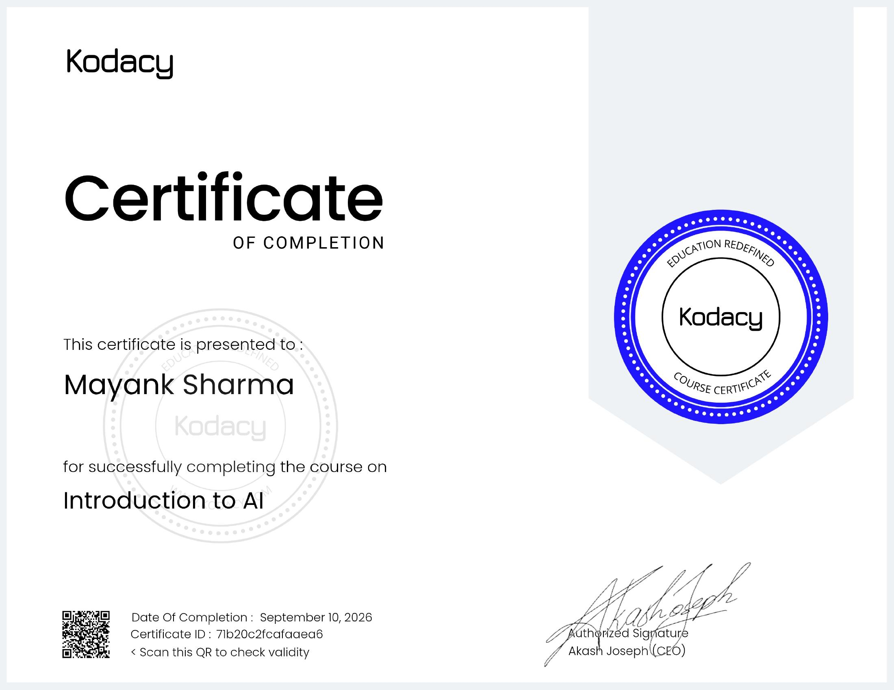

CHAPTER 4: PROJECT DESCRIPTION

4.1 Introduction
Artificial Intelligence (AI) is one of the most transformative technologies of the present era, enabling machines to perform tasks that traditionally required human intelligence, such as learning, reasoning, problem-solving, perception and language understanding. As part of my academic curriculum for the B.Tech Computer Science and Engineering programme at IILM University, Greater Noida, I undertook an AICTE-recognised virtual internship on “Introduction to AI” offered by Kodacy. This internship was designed to provide a strong foundation in the core concepts, techniques and real-world applications of Artificial Intelligence and Machine Learning (AIML).
The internship covered foundational topics including the history and evolution of AI, types of AI (narrow, general and super AI), machine learning paradigms (supervised, unsupervised and reinforcement learning), neural networks, natural language processing, and the ethical considerations surrounding the deployment of AI systems. This report documents the learning journey, the organization under which the internship was completed, the objectives pursued, the tools and technologies explored, and the outcomes achieved during the internship period.

4.2 Organization Profile
The internship was completed under Kodacy, an ed-tech platform that focuses on redefining education by offering industry-relevant, skill-based virtual internship and certification programs to students across various technical domains. Kodacy provides AICTE Virtual Internship programs that allow students to gain practical exposure to emerging technologies such as Artificial Intelligence, Machine Learning, Data Science and Web Development, through structured online modules, assessments and mentorship.
Kodacy's mission, as reflected in its tagline “Education Redefined,” is to bridge the gap between academic learning and industry requirements by offering flexible, self-paced and practically-oriented training programs, thereby enabling students to build job-ready skills alongside their formal education.

4.3 Problem Statement
Despite AI being a rapidly growing field with wide-ranging applications, many undergraduate students lack structured, hands-on exposure to its fundamental concepts within a typical classroom setting. There exists a gap between theoretical knowledge taught in academic curricula and the practical, applied understanding required by the industry. This internship aimed to address that gap by providing a structured, self-paced learning path covering the fundamentals of AI, along with practical exercises to reinforce conceptual understanding.

4.4 Project Objectives
- To understand the fundamental concepts, history and scope of Artificial Intelligence.
- To study the different types and branches of AI, including Machine Learning and Deep Learning.
- To gain a working understanding of supervised, unsupervised and reinforcement learning techniques.
- To explore the basic architecture and working of neural networks.
- To understand real-world applications of AI across industries such as healthcare, finance, and automation.
- To become familiar with the ethical, social and safety considerations associated with AI systems.

4.5 Scope of the Project
The scope of this internship was limited to building a conceptual and foundational understanding of Artificial Intelligence rather than developing a full-scale deployable AI product. It covered the theoretical underpinnings of AI and Machine Learning, an overview of commonly used algorithms and tools, and an introduction to how AI systems are designed, trained and evaluated. The internship also touched upon the broader implications of AI adoption in society, industry and everyday life, providing a well-rounded introductory exposure to the field.

4.6 Technologies and Tools Used
- Python – primary programming language used for AI/ML concepts and examples.
- Jupyter Notebook – for interactive coding, experimentation and visualization.
- NumPy and Pandas – for numerical computation and data handling.
- Scikit-learn – for implementing basic machine learning algorithms.
- Matplotlib – for data visualization and plotting results.
- Online learning modules and assessments provided by the Kodacy platform.

4.7 System Architecture
A typical AI/Machine Learning system follows a structured pipeline. The general architecture studied during the internship can be summarized as follows:
- Data Collection – gathering raw data relevant to the problem statement.
- Data Pre-processing – cleaning, transforming and preparing data for analysis (handling missing values, normalization, encoding).
- Feature Selection/Extraction – identifying the most relevant attributes that influence the outcome.
- Model Selection and Training – choosing an appropriate algorithm (e.g. regression, classification, clustering) and training it on the prepared dataset.
- Model Evaluation – testing the trained model on unseen data using metrics such as accuracy, precision, recall and F1-score.
- Deployment and Monitoring – integrating the model into a real-world application and monitoring its performance over time.

4.8 Methodology
The internship followed a self-paced, module-based methodology delivered through the Kodacy virtual internship platform under the AICTE Virtual Internship scheme. Learning was organized into structured modules, each covering a specific sub-topic within Artificial Intelligence, accompanied by reading material, video content and short quizzes/assessments to reinforce understanding. Concepts learned were further reinforced through hands-on practice using Python and standard AI/ML libraries on sample datasets. On completion of all modules and the final assessment, a certificate of completion was issued by Kodacy, confirming successful completion of the “Introduction to AI” internship.

4.9 Expected Outcomes
- A clear conceptual understanding of what Artificial Intelligence is and how it differs from traditional programming.
- Familiarity with core machine learning paradigms and common algorithms used in practice.
- Basic hands-on exposure to Python-based tools used for AI/ML development.
- Awareness of real-world AI applications and their impact across various industries.
- An appreciation of the ethical and societal considerations involved in building and deploying AI systems.
- A strong foundation to pursue further, more advanced studies and projects in AI and Machine Learning.

4.10 Certificate of Completion
The certificate of completion issued by Kodacy for successfully completing the “Introduction to AI” course, in the name of Mayank Sharma, dated September 10, 2026 (Certificate ID: 71b20c2fcafaaea6), has been attached in Chapter 3 of this report as proof of completion of the internship.

CHAPTER 5: BIBLIOGRAPHY/REFERENCES
1. Russell, S., & Norvig, P. (2020). Artificial Intelligence: A Modern Approach (4th ed.). Pearson.
2. Kodacy. (2026). Introduction to AI – Course Modules. Retrieved from Kodacy virtual internship platform.
3. AICTE. (2026). AICTE Internship Policy and Guidelines. All India Council for Technical Education.
4. Scikit-learn Developers. Scikit-learn: Machine Learning in Python. Retrieved from https://scikit-learn.org
5. Python Software Foundation. Python Language Reference. Retrieved from https://www.python.org

